SPRINT-1

TEAM ID: PNT2022TMID14780

PROJECT: IOT BASED SMART CROP PROTECTION FOR AGRICULTURE

CODE: To detect animals in crop

#include<LiquidCrystal.h>

LiquidCrystal lcd(11,12,5,4,3,2);

int led = 7;

int pirPin = 13;

void setup(){

pinMode(6,OUTPUT);

lcd.begin(16,2);

pinMode(led, OUTPUT);

pinMode(pirPin, INPUT);

Serial.begin(9600);

}

void loop()

{

lcd.blink();

int a = digitalRead(pirPin);

Serial.println(a);

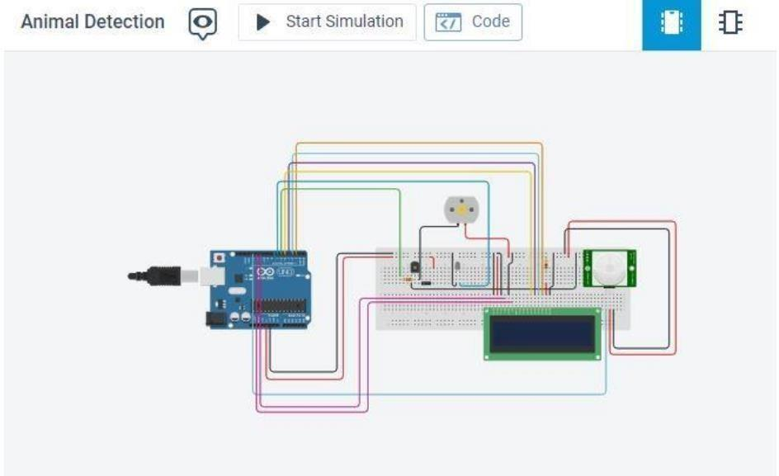

if(a==HIGH)

{

lcd.setCursor(1,1);

lcd.print("Animal Detected");

digitalWrite(led, HIGH);

digitalWrite(6, LOW);

delay(2000);

lcd.clear();

}

else

{

digitalWrite(led, LOW);

digitalWrite(6, HIGH);

lcd.clear();

}

}



int moistureValue;

float moisture_percentage;

void setup()

{

Serial.begin(9600);

}

void loop()

{

moistureValue = analogRead(A0);

moisture_percentage = ((moistureValue/539.00)*100);

Serial.print("\nMoisture Value : ");

Serial.print(moisture_percentage);

Serial.print("%");

delay(1000);

}

